**LP-2 (Cloud Computing) :- Assignment 1**

**Name:** Mitesh M. Adake **Roll No:** 31401

**Batch:** K4

# **Title:** Case Study on Microsoft Azure

**Problem Definition:** Case study on Microsoft azure to learn about Microsoft Azure is a cloud computing platform and infrastructure, created by Microsoft, for building, deploying and managing applications and services through a global network of Microsoft-managed data centres.

## Cloud Computing

Cloud Computing is nothing but a practice of providing Cloud Services (Storage, Computation, Databases, Security, etc.) on rent and also through a network that can be accessed over the internet*.* These services are divided into three main categories or types of cloud computing: infrastructure as a service ([IaaS)](https://searchcloudcomputing.techtarget.com/definition/Infrastructure-as-a-Service-IaaS), platform as a service ([PaaS)](https://searchcloudcomputing.techtarget.com/definition/Platform-as-a-Service-PaaS) and software as a service ([SaaS)](https://searchcloudcomputing.techtarget.com/definition/Software-as-a-Service).

## Infrastructure as a service (IaaS)

IaaS-cloud providers supply these resources on-demand from their large pools of equipment installed in [data centres.](https://en.wikipedia.org/wiki/Data_centers) For [wide-ar](https://en.wikipedia.org/wiki/Wide_area_network)ea connectivity, customers can use either the Internet or carrier cloud (dedicated [virtual private networks)](https://en.wikipedia.org/wiki/Virtual_private_network). To deploy their applications, cloud users install operating-system images and their application software on the cloud infrastructure. In this model, the cloud user patches and maintains the operating systems and the application software. Cloud providers typically bill IaaS services on a utility computing basis: cost reflects the amount of resources allocated and consumed.

## Platform as a service (PaaS)

The capability provided to the consumer is to deploy onto the cloud infrastructure consumer-created or acquired applications created using programming languages, libraries, services, and tools supported by the provider. The consumer does not manage or control the underlying cloud infrastructure including network, servers, operating systems, or storage, but has control over the deployed applications and possibly configuration settings for the application-hosting environment.

## Software as a service (SaaS)

The capability provided to the consumer is to use the provider's applications running on a [cloud infrastructure.](https://en.wikipedia.org/wiki/Cloud_infrastructure) The applications are accessible from various client devices through either a thin client interface, such as a web browser (e.g., web-based email), or a program interface. The consumer does not manage or control the underlying cloud infrastructure including network, servers, operating systems, storage, or even individual application capabilities, with the possible exception of limited user-specific application configuration settings.

**Microsoft Azure**

Microsoft Azure is a Microsoft cloud service provider that provides cloud computing services like computation, storage, security and many other domains. Microsoft is one of the global leaders when it comes to Cloud solutions and global cloud infrastructure. Microsoft Azure provides services in 60+ global regions and serves in 140 counties. It provides services in the form of Infrastructure as a service, Platform as a Service and Software as a service. It even provides server less computing meaning, you just put your code and all your backend activities as managed by Microsoft Azure. It easily integrates with Microsoft Products making it very popular using Microsoft products. This platform is now 10 years old and it picked up to compete with the best of the best.

**Services Provided By Azure**

## 1) Computer services

Web Jobs, applications that can be deployed to an App Service environment to implement background processing that can be invoked on a schedule, on demand, or run continuously. The Blob, Table and Queue services can be used to communicate between WebApps, iOS Software’s and WebJobs and to provide state.

## 2) Mobile services

Mobile Engagement collects real-time analytics that highlight users’ behaviour. It also provides push notifications to mobile devices. HockeyApp can be used to develop, distribute, and beta-test mobile apps.

## 3) Communication services

Azure Communication Services offers an SDK or creating web and mobile communications applications that include calling, and web based chat. Data management Azure Data Explorer provides big data analytics and [data exp](https://en.wikipedia.org/wiki/Data_exploration)loration capabilities.

## 4) Developer

Azure Automation provides a way for users to automate the manual, long-running, error-prone, and frequently repeated tasks that are commonly performed in a cloud and enterprise environment. It saves time and increases the reliability of regular administrative tasks and even schedules them to be automatically performed at regular intervals. You can automate processes using runbooks or automate configuration management using Desired State Configuration.

## 5) Azure AI

Microsoft Azure Machine Learning (Azure ML) provides tools and ML frameworks for developers to create their own machine learning and AI services. Microsoft Azure Cognitive Services are a set of prebuilt APIs, SDKs and customizable services for developers, including perceptual and cognitive intelligence covering speech recognition, speaker recognition, neural speech synthesis, face recognition, computer vision,

OCR/form understanding, natural language processing, machine translation, and business decision services.

Most AI features appeared in Microsoft’s own products and services (Bing, Office, Teams, Xbox, and Windows) are powered by Azure Cognitive Services.

**Pros of Azure:**

**On-Demand Scalability**: Microsoft Azure ensures your applications and data is distributed well enough that means you never run short of Server space. It also means your applications do not run on a single server making them available even in dire situations. Since these resources are properly clustered out and they can scale at will and in no time, your applications function very differently then they would in an on premise architecture.

**Cost Effective**: One of the major benefits with cloud service providers is the cut down of upfront costs. Since you can configure and scale at will, you are not required to invest heavily here. Microsoft Azure ensures small scale investment does not require upfront costs. Also when it comes to people who have signed up contracts, they get heavy discounts. It also offers to Pay as go, model, meaning you get costcutting in the right sense.

**Hybrid Environments**: Microsoft Azure benefits with its Hybrid approach. Meaning, with Microsoft Azure you can build Hybrid infrastructures, where your resources can partially reside on the cloud and can partially operate from an on premise infrastructure. Hence you are safe from costly workaround.

**Big data Applications**: Hadoop and Big data are the need of the hour. With data increasing exponentially we need applications that can help process this data. Microsoft Azure brings this capability of processing large volumes of data on top of its cloud platform. Azure HDInsight ensures you can use Apache Hadoop as a cloud solution. This is a power-packed service that lets you deal with large data volumes. That means your data crunching becomes easier.

**Integration Capabilities**: Microsoft has been in the software industry for decades. It has wide reach in the software market and not many can compete with it when it comes to customer base and stack of products it offers. The advantage for Microsoft Azure here is that it readily integrates with most of these products. Be it, connecting to SaaS, PaaS, IaaS applications or even something like Visual Studio or Active Directory, Microsoft Azure has you covered. Hence you can now leverage ERPs and CRMs to enhance your business capacity to a greater level.

**Storage and Security**: Microsoft Azure lets you store data in form of files, objects, structured and unstructured data and a lot more. This happens reliable and securely.Talking of security Microsoft Azure ensures high level of security for your applications. It ensures all the resources in Azure cloud are guarded with firewalls and data is moved over the network with encryption. You have access to authentication and access management meaning you data and application are secure to the core.

**Data Backup and Recovery**: With Microsoft Azure, you have an option of backing up your data in different Azure regions or data centres. You can maintain as many as six copies of your data. This signifies that the chance of losing your data on Microsoft Azure is minimal. When it comes to reliability your data is available 99.9 percent.

**Cons of Azure:**

## 1) Requires Management

As with anything, there are a couple of potential cons with Microsoft Azure. Unlike SaaS platforms where the end-user is consuming information (for example, Office 365), IaaS (Azure) moves your business’ compute power from your data centre or office to the cloud. As with most cloud service providers, Azure needs to be expertly managed and maintained, which includes patching and server monitoring.

## 2) Requires Platform Expertise

Unlike local servers, Azure requires expertise to ensure all moving parts work together efficiently. A common mistake by business administrators that are not fully engaged in how well (or poorly) their cloud servers are operating is to over-provision cloud services. While a common mistake, on-premise servers’ compute power does not translate equivocally in the cloud, potentially costing businesses thousands of dollars per year.

# **Use Cases of Microsoft Azure**

Microsoft has many popular customers out there, here are some use cases

**University Of Toronto**: This is the largest Canadian university and leads the global front when it comes to research at an institutional fare. It made use of Microsoft Azure to avoid heavy hardware renewal costs. It migrated some of its activities to Microsoft Azure Cloud. With it, the university managed to transform IT processes, saving a lot of time

**AkzoNobel**: AkzoNobel is a popular Dutch Company that leads way in paint and coating business. It serves in more than 100 countries and always needs better connectivity across the globe. It harnessed the power of Microsoft Azure IoT services to improve its performance and connectivity at a global level

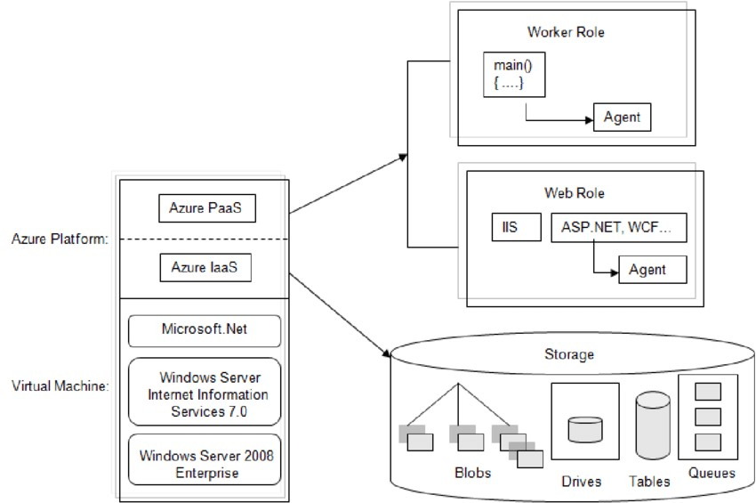

**Architecture of Microsoft Azure**

**References:**

1. <https://blog.icorps.com/pros-and-cons-microsoft-azure>
2. <https://azure.microsoft.com/en-au/resources/customer-stories/>
3. <https://azure.microsoft.com/en-us/>
4. <https://en.wikipedia.org/wiki/Cloud_computing>
5. <https://searchcloudcomputing.techtarget.com/definition/cloud-computing>
6. https://www.mygreatlearning.com/blog/microsoft-azure/